**METHODOLOGY GUIDE**

**to Analyse Categorization of Strengths and Failure mechanism**

**Objective**

This tool should help the team to analyse the different design and construction elements of existing house typologies, with the aim to rank their importance and establish prioritization levels. It is a tool to support decision taking in relation to WHAT the Protocol wants to focus on.

**How to complete the table**

The teams should fill in one table per House typology identified in the Context analysis (step 1).

**Column A: define the Element or Category that is being analysed**

In this column of `House elements or categories´ should be introduced the weak and strong elements identified in the context analysis (step 1) in relation to every shelter typology. It should be considered structural or construction elements looking at the safety and durability of the house, but also design elements that allows the adequate use of the spaces to do daily activities to all inhabitants in a safe and dignified way. Depending on the context, these elements could be related as well to the access to adequate shelter (rent, host families, hotel, occupancy, etc.) or to protection issues. In case there is any doubt or the team prefers to check if all important elements are listed, the template includes a support sheet `Column A-checklist of elements´ with a list of possible elements that can be analysed based on the context and typology. Choose only the elements that apply to the typology analysed and findings and place one single element in one line, in order to analyse them separately.

**Column B: Describe briefly the Element or Category (Finding)**

For each element identified, explain the specific finding, based on the context analysis (step 1).

Sometimes one element can have two different findings. In this case, include another line in order to analyse it separately.

E.g. taking as example a house typology with wooden structure, thatch roof that includes a veranda and no use of lintel at windows, the table could look like the following:

| **House element (category)** | **Element description** |
| --- | --- |
| Column or Pole | Structural wooden poles are humid at the bottom |
| Lintel | No lintels at the windows |
| Foundation | None or very shallow foundation |
| Roof | Grass thatch roof with bamboo purlins and additional strings |
|  | Overhang of the roof creating veranda or outdoor covered space at the front used also for cooking |

**Column C: Failure mechanism**

Describe which is the exact failure mechanism of the element identified. Try to provide detail on the cause of the failure.

See the following table as an example:

| **House element (category)** | **Element description** | **Failure mechanism** |
| --- | --- | --- |
| Column or Pole | Structural wooden poles are humid at the bottom | Deterioration of the structure base due to capillarity and lack of protection |
| Foundation | None or very shallow foundation | House collapses with strong winds |
| Lintel | No lintels at the windows | Lack of lintels, risk of wall to collapse |
| Roof | Grass thatch roof with bamboo purlins and additional strings |  |
|  | Overhang of the roof creating veranda used also for cooking | High flammable roof material without protection |
|  |  | Smoke in the inside of the shelter, poor ventilation |

**Column D: Positive Construction Practice (strength)**

Try to identify as well the strengths of the house design or construction technique, in order to reinforce the practice when implementing the programme. One element could have been listed because it has been identified as a positive practice that should be promoted wider. See the following table as an example:

| **House element (category)** | **Element description** | **Failure mechanism** | **Positive Construction Practice (strength)** |
| --- | --- | --- | --- |
| Column or Pole | Structural wooden poles are humid at the bottom | Deterioration of the structure base due to capillarity and lack of protection |  |
| Foundation | None or very shallow foundation | House collapses with strong winds | *On Black cotton soil:* positive to not have deep foundations |
| Lintel | No lintels at the windows | Risk of wall to collapse |  |
| Roof | Grass thatch roof with bamboo purlins and additional strings |  | Roof resists winds due to well thatched and clamped elements to the walls |
|  | Less weight in case of collapse due to earthquake |
| Overhang of the roof creating veranda or outdoor covered space at the front | High flammable roof material without protection |  |
|  | Smoke in the inside of the shelter, poor ventilation | Roof is more durable, prevention of termites and other insects |

**Column E: Mechanism ranking**

This ranking will provide an overview on which are the most important elements to focus on when deciding on developing EIC material.

Rank the importance of the element analysed as part of the global house taking into account physical safety, health preservation, carrying out daily activities and protection measures and based on the frequency with which this mechanism is seen. Try to score every element by placing it in the following table:

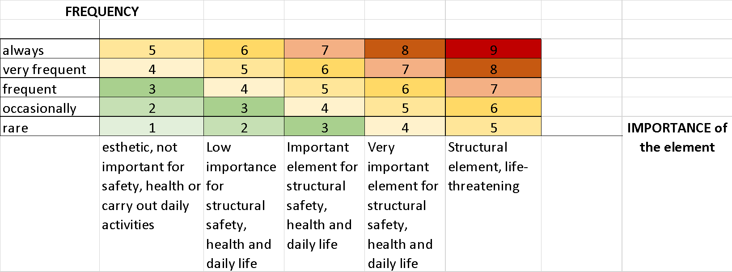

It is important to have technical people amongst the team to evaluate the importance of the construction element as a component of the house. When ranking the different elements ask yourself the following questions:

* Does this element compromise the stability of the construction?
* Can this failure cause a domino effect in other elements of the house and trigger more serious problems to the structural safety of the house?
* Does the design failure hinder any inhabitant to do all daily activities inside the house without impediment?
* Does the failure of this element or design have an influence on the health and well-being of inhabitants?

In case it is a positive construction practice rank it as well asking yourself:

* Does this element reinforce the stability of the construction?
* Is this practice easy to transfer and copy by other house owners?
* Does this practice benefit the health and well-being of inhabitants?

**Columns F to K: analysis of possible Solutions**

The template distinguishes between interventions in existing houses (retrofitting works) and design and construction of new houses. Solutions and rankings applicable to retrofitting should be analysed in columns F to H. Solutions and ranking corresponding to new constructions should be analysed in columns I to K. It is very important to separate both activities, as the solutions and difficulties to solve specific failure mechanisms can vary very much. This division can help later to take decisions on the convenience of focusing on existing buildings or concentrating on new constructions. Each failure mechanism will have at least two solution options linked with a ranking number targeting existing constructions and planned houses.

**Column F and I: Possible Solution**

Try to brainstorm and discuss possible solutions to the specific failure mechanism in your team. This team should include construction and shelter professionals to validate the possible solutions and consider as well the local building culture and practice in the area. Write down the solutions you might find most appropriate, providing comments in the table to allow a variety of solution options.

It is very important to identify and define areas with the same characteristics which face the same challenges (homogeneous zones), and provide solutions to specific issues such as hazards, soil type or exposure. Analyse and provide different solutions considering the vulnerability criteria of the houses facing these issues. Depending on the context classification can be made by:

* Types of hazards such as earthquakes, floods, strong winds, droughts, extreme cold weather, landslides, volcanic eruption, pollution, etc.
* Type of soils identifying areas with the same geological characteristics such as rock, sandy soil, peat soil, silt soil, swelling clay, etc.
* Type of exposure to a specific hazard (risk) like construction on slopes, inside river or on river banks, high density neighbourhoods, etc.

Please, see below an example on how this classification could look like:

| **House element (category)** | **Element description** | **Failure mechanism** | **Positive Construction Practice (strength)** | ***Existing House***  **Possible Solution** | ***New House:* Possible Solution** |
| --- | --- | --- | --- | --- | --- |
| Column or Pole | Structural wooden poles are humid at the bottom | Deterioration of the structure base due to capillarity and lack of protection |  | ***FLOOD prone area:*** Protect based of the poles with water-resistant material. | ***FLOOD prone area:***  *Separate* wooden pole from ground with concrete base |
| Structural wooden poles are not tied with other structural element | House collapses easily |  | ***Earthquake /Wind prone areas:***  Insert bracings and straps | ***Earthquake /Wind prone areas:*** include good tied beams, bracings and reinforcement straps |
| Foundation | None or very shallow foundation | House collapses with strong winds | ***Loam soil*** | ***Loam soil*** | ***Loam soil:*** include deeper foundations (1m) |
| ***Black cotton soil:*** positive to not have deep foundations | ***Black cotton soil***: try to tie structure on the bases to distribute load | ***Black cotton soil:*** use raft foundation (slab) |
| Lintel | No lintels at the windows | Risk of wall to collapse |  | ***All:*** insert strong enough timber on top of the window | ***All:*** include lentils in the design and construction |

**Column G and J: Solution ranking**

This ranking is to help prioritize the difficulty of possible solutions looking at the structural importance of the element. Every identified solution should get a ranking number. This scoring can help later to take a decision on what messages to prioritize to have a quick impact.

Try to answer the following questions:

* Do possible solutions already exist in the local building culture to solve the problem?
* Is it easy to repair or to fix?
* Are EIC materials already known that tackle this issue?

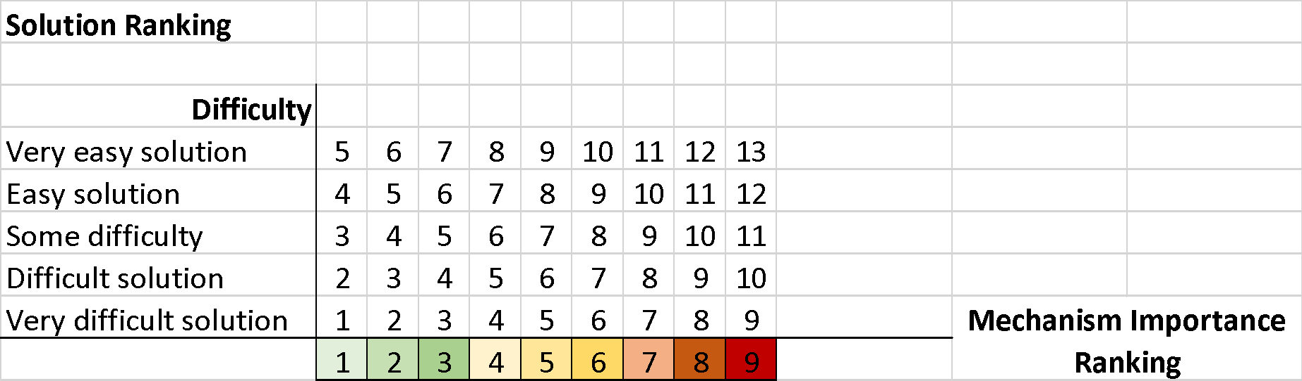

**Column H and K: Additional comments**

Include any additional comment on the element that is being analysed which explains the logic of the ranking decision or which should be taken into account in a later stage when deciding the strategy.

**Column L: Are EIC available?**

For each element and possible solution, specify if EIC material is already known or available. Ideally it should be EIC material already tested and adapted to the specific country, but if not, it can be any other material. EIC material can be graphic (guidelines, posters, hand-outs, etc.), audio (radio messages, phone messages, etc.), performance (theatre, model houses, video, etc.) or others (e.g. phone messages). You can also place comments on the available EIC material, e.g. if one specific resource has been already tested or if it should be adapted before use.