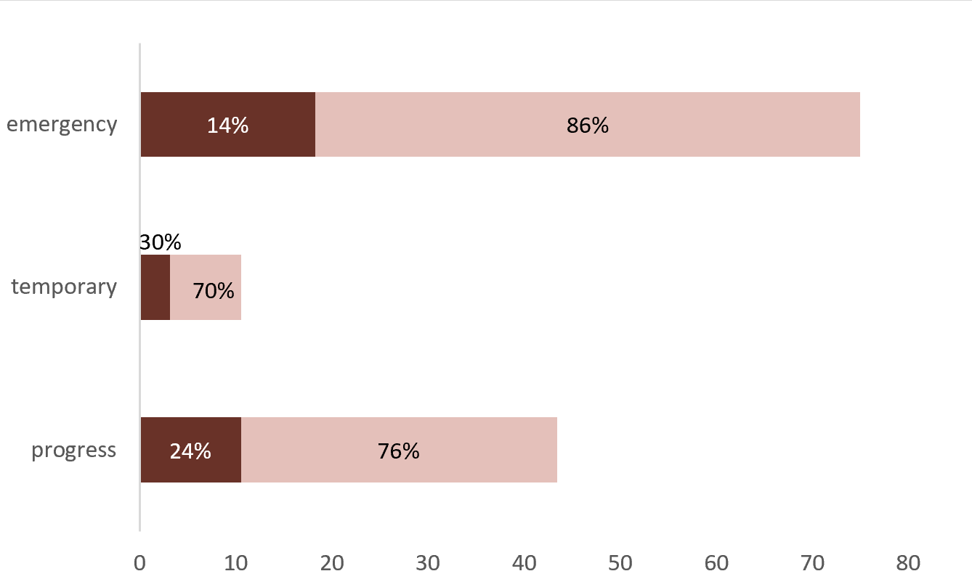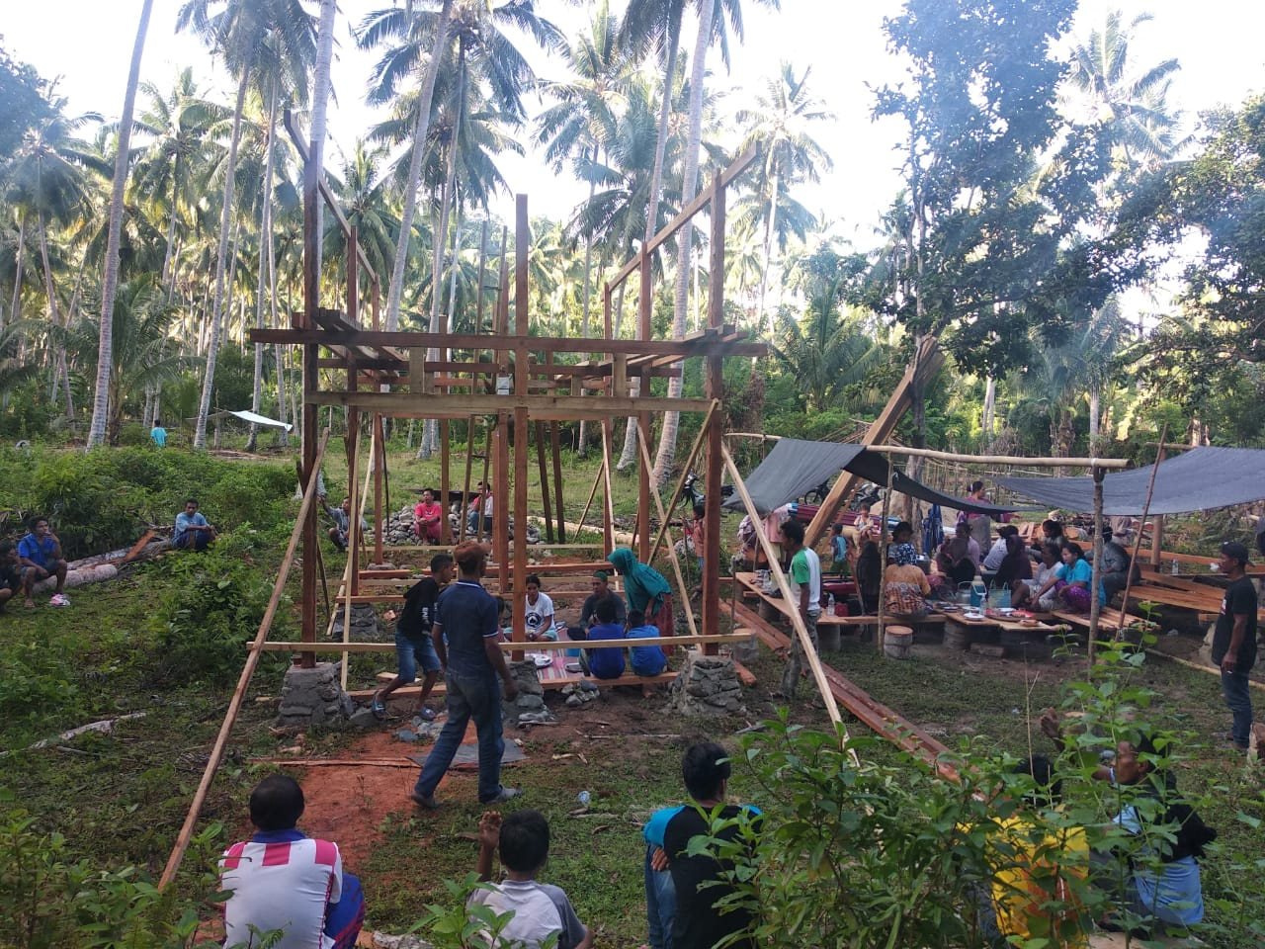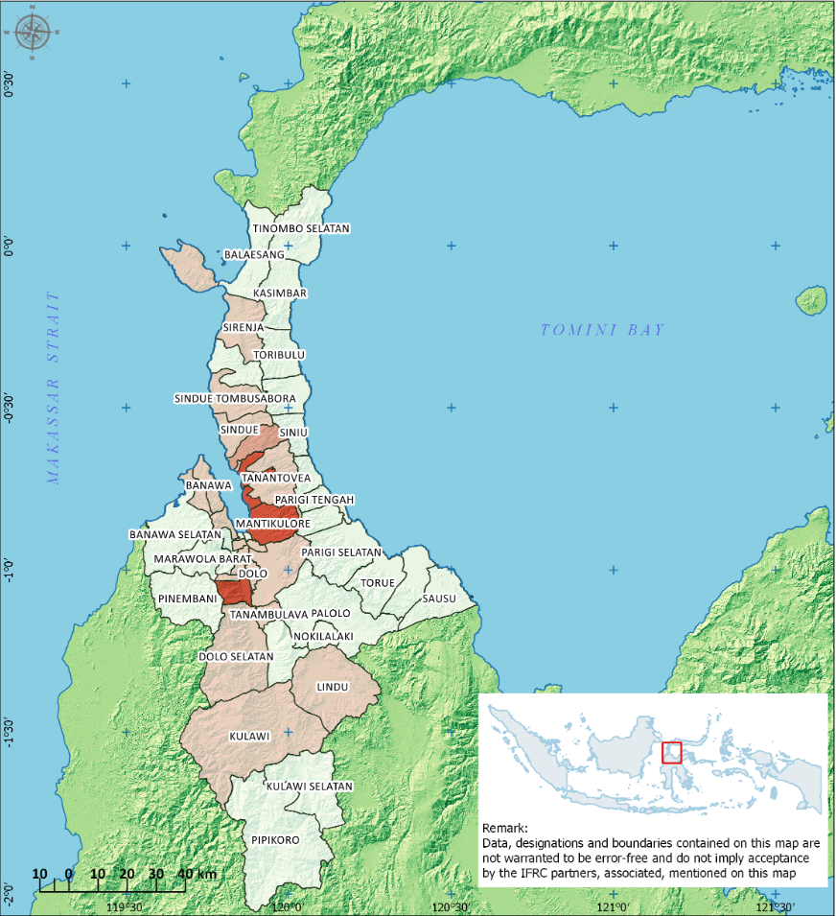

Temporary Shelters (Completed vs Needs)

Tents

Tarpaulins

Temporary Shelters (Individual)

Temporary Shelters (Completed)

Temporary Shelters (Needs)

Temporary Shelters (Collective)

Thousands of HH

**KEY FIGURES (HH)**

Completed Temporary Shelter

Completed Emergency Shelter

Source: Wanda Chanafiar/ Relief Box

**Targeted**: 22,971 HH or 114,855 people

Disaster-affected population (Government data)

Population in the affected sub-districts (Census 2014)

Cluster Partners

CENTRAL SULAWESI, INDONESIA

**NEED ANALYSIS**

* A massive quake hit the island nation’s Central Sulawesi province. The magnitude-7.5 temblor struck at 5:02 p.m. Friday, Sept. 28, generating a devastating tsunami and liquefaction.
* At least 4,547 people have been killed and nearly 173,000 people displaced (11/03/2019).
* Estimated over 100,000 houses are affected with 4,050 houses gone and more than 30,000 houses heavily damaged. However, the actual figure is likely to be much higher.

**RESPONSE**

* Over 100 cluster partners are recorded in the shelter sub cluster. Of these around 20+ agencies report and engage regularly in the sub-cluster.
* Most agencies are currently focusing in providing temporary shelters (individual or collective).
* Shelter coordination meeting is conducted every two weeks, with SAG and district focal points have been established.

**GAPS / CHALLENGES**

* Lack of reliable data due to conflicting definitions of displacement and damage.
* Quality of shelter assistance varies and not according to the agreed shelter standards
* People are reluctant to move to the government-led collective shelters program due to uncertainties with the available facilities and services.
* Housing, land, and property rights due to relocation of families to safe zones
* Political situation with the upcoming general election in April 2019
* Floods and landslides risk due to the ongoing rainy season. Aftershocks also still occurred.

Photographer / Organisation, Year

**SHELTER SUB CLUSTER TEAM**

National Coordinator

Iyan Kusmadiyana (Ministry of Social Affairs)

[iyankusmadiana@gmail.com](mailto:iyankusmadiana@gmail.com) / +62 819-3145-8272

National Co-Lead

Wahyu Widayanto (IFRC)

[Wahyu.widayanto@ifrc.org](mailto:Wahyu.widayanto@ifrc.org) / +62 819-737-529-71

Information Management Coordinator

Hijaz Jalil (IFRC)

[hijaz.jalil@ifrc.org](mailto:hijaz.jalil@ifrc.org) / +62 811 611 2880

Technical Advisor

Dave Hodgkin (IFRC)

[dave.hodgkin@gmail.com](mailto:dave.hodgkin@gmail.com) / +62-813-920-99-666

Communication Focal Point

Avianto Amri (IFRC)

[avianto.amri@gmail.com](mailto:avianto.amri@gmail.com) / +62-855-210-66-10

**KEY DATES**

26 October 2018: End of emergency relief period

24 April 2019: End of emergency transition period, r

**KEY DOCUMENTS**

* [Temporary Shelter Standards](https://www.sheltercluster.org/indonesia-tsunamiearthquakes-sep-2018/documents/temporary-shelter-standards-central-sulawesi)
* [Meeting Minutes](https://www.sheltercluster.org/indonesia-tsunamiearthquakes-sep-2018/library/shelter-sub-cluster-indonesia-meeting-minutes)
* [Maps](https://www.sheltercluster.org/response/indonesia-tsunamiearthquakes-sep-2018/documents?information_management=Maps+and+GIS)

**KEY LINKS**

* [Country page on ShelterCluster.org](https://www.sheltercluster.org/response/indonesia-tsunamiearthquakes-sep-2018)
* [Country page on Indonesia’s Shelter Sub Cluster](http://bit.ly/shelterklaster) Website
* [Country page on ReliefWeb](https://reliefweb.int/disaster/eq-2018-000156-idn)

**KEY FIGURES**

109 984 K / 173 K

**CLUSTER MEMBERS TARGET**