**METHODOLOGY GUIDE**

**Stakeholders and potential Audience Analysis**

**What is a Stakeholder and Audience Analysis?**

Stakeholder analysis is a process of systematically gathering and analysing qualitative information to determine whose interests should be taken into account when developing and/or implementing a programme.

**Objective**

This tool should help the TWG/team to analyse identified Stakeholders and potential Audiences in order to interact more effectively with key actors and to increase support for a given policy or programmes by understanding linkages between different stakeholders and having a more effective project planning looking at synergies. The analysis should identify key actors in advance, grouping them later according to their potential level of participation, interest and influence in the project's objectives. It is a tool to support taking decisions in relation to WHOM the Protocol wants to get involved with.

**Previous planning**

The TWIG should form a small ‘working group’ (four to five people) whose members should go through the process of stakeholder analysis in a participatory way. Whenever possible, the working group should represent distinct interests and organizations. Having members with differing points of view can also be helpful in interpreting the qualitative and, at times, ambiguous data that emerge.

The context analysis (Step 1) includes a Stakeholder Register, in which the teams would have identified key stakeholders related to construction, education, social and cultural live, communication and policy at different levels (local, district and national). This list should be taken as a starting point for the analysis, but more stakeholders can be added throughout the process.

In case no sufficient information is available about one identified stakeholders, it is possible to conduct interviews to get the main information about their knowledge, position, interest, alliance, resources, power and leadership related to the sheltering process.

To do the stakeholder analysis in a participatory way and to give the chance for a rich discussion amongst WG members, it is suggested to use a flip chart, coloured sticky notes and pens. The suggested process will be described later in this document. Conclusions of this discussion can then be transferred into the excel template (Stakeholder-mapping sheet).

**How to complete the table – PART 1**

**Part 1 – Insert information from Stakeholder Register**

In order to identify as many stakeholders as possible, try to think about different action levels (national, district and local) and stakeholders linked with different community groups (gender, age, diversity, etc.). It is key to look at a variety of sectors such as **political, social, construction, education, communication, health, security, economic, religious, cultural, legal, ecological, logistical, etc**. Some will have more relevance to the project than others, but try to make a comprehensive list to better understand synergies and linkages.

Don´t forget to include as well as stakeholders' final beneficiaries, such as the households which will self-construct or retrofit their houses.

**Column A: Stakeholder Group**

Try to organise the actors in groups to simplify classification. The template has some groups defined just as guidance, but they can be changed and adapted as required in order to reflect the reality and complexity of the specific context.

**Column B: Stakeholder Name**

Specify the Stakeholder Name or in case there is no specific person, specify the entity.

**Column C: Level, Role, Title, Department, etc.**

Indicate all details about area of responsibility and competence (national, district or community level), and if applicable exact role, title or responsible department.

**Column D: Contact Details**

Provide any contact detail that allows reaching a specific stakeholder, such as Name, Phone number, Email, Address, etc.

**Column E: Stake.**

Specify which their areas of competencies are. Highlight the ones that are related to the project's objectives.

**Column F: Our Expectation (what do we want or need from this stakeholder?)**

Based on the area of competences and possible linkage with the objectives of the project, provide first ideas on what we expect from this actor. Why are we considering this actor a stakeholder to the project? What are the potential synergies with this stakeholder? What do we –potentially- want or need from this stakeholder? In case the team doesn't see a direct connection to the project or still doesn't know which could be the linkage, leave it blank or note ‘unknown’.

**Stakeholder Analysis**

The analysis methodology explained below is a suggestion, but it can be done in different ways. The WG should find the best process to explore, in a participatory way, interest and priority of stakeholders and their possible support or resistance to the projects objectives.

1.- First step is to map the stakeholders.

Take a flip chart or any other surface in which you can stick notes and write on. Draw a graph in which the vertical axe defines **power and influence level** and the horizontal axe reflects the **interest and priority level**. Influence axe will go from less power at the bottom to high power at the top. Interest axe will go from low priority at the left to high priority at the right side.

The next figure shows an example on how to draw this graph.

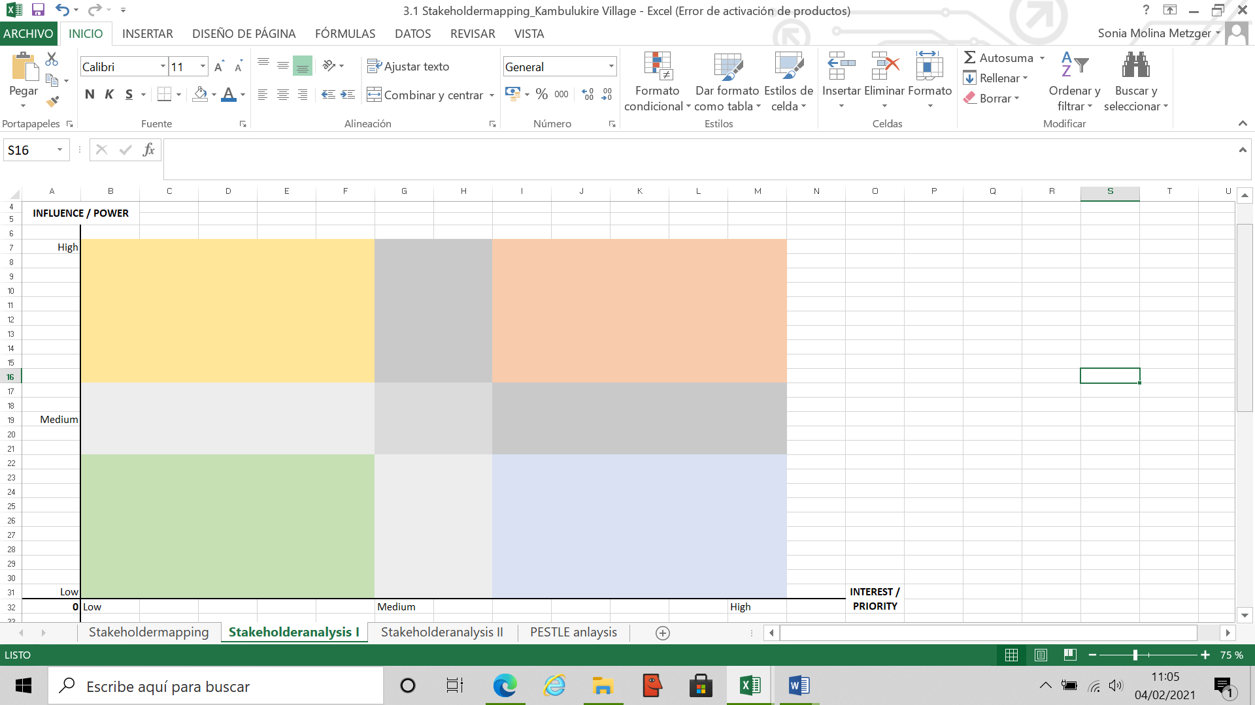

Write on the sticky notes of all the identified stakeholders, only one stakeholder in every paper. Discuss amongst the WG members about the power or influence the specific stakeholders have in relation to the shelter sector, as well as their potential interest or priority in your support and in seeing any change related to the project's aims. Place the notes/stakeholders in the graph considering these two factors discussed. Continue discussing until you have placed all stakeholders in the graph. During the discussion you can relocate the stakeholders inside the graph until the WG has reached a consensus.

The group can ask and discuss for every stakeholder the following questions (coincide with columns `G’ to `N’ of the excel sheet). These question will help to place the different actors in the graph:

- **Priorities**: What is important to this stakeholder? What is his/her agenda? What does he/her incentivize in general, what are his/her priorities in life?

- **Motivation**: What can make the project attractive to the stakeholder? How can the stakeholder specifically benefit from this project?

- **Impact:** To what level will the project have an impact over the stakeholder? How can the project influence this stakeholder, directly or indirectly? What impact could he/she expect?

- **Influence:** How much influence does the stakeholder have over the process and goals of the project? How can he/she influence the good development of the project? How much influence do they have over decision making policies? Try to find out their influence in the decision making process. Influence upwards.

- **Trust:** How much influence does this stakeholder have over our target population? Is this stakeholder trusted and listened to by our target group and could influence their decision making process? Influence downwards.

- **Supporter:** Could this stakeholder contribute to Project objectives? How? What could be their role in the project?

- **Opponent:** Could the stakeholder have any interest in blocking the project? How? Is there a risk of not reaching the Projects objectives if not engaged? How likely can this opposition be?

- **Attitude:** What is the perceived attitude towards the project? E.g. open, excited, expectant, suspicious, indifferent, etc. Is there a risk in case he/she does not engage with the project?

2.- Define level and ways of interaction with the Programme

Depending on the stakeholders position in the diagram, we could classify them in four groups:

* Actors who could play a **key role** during the process because they have influence and are also interested in changing things (red quadrant)
* Actors whose **needs should be met** as they have high influence, but are less interested in the outcomes of the project (yellow quadrant).
* Actors we would need to **show conside**ration because of their level of interest in the cause, but without power (blue quadrant/ light yellow quadrant)
* Actors that are **least important** as they do now show interest and do not have any specific influence (green quadrant)

The optimum would be to increase the level of interest over the course of the programme of stakeholders with less interest.

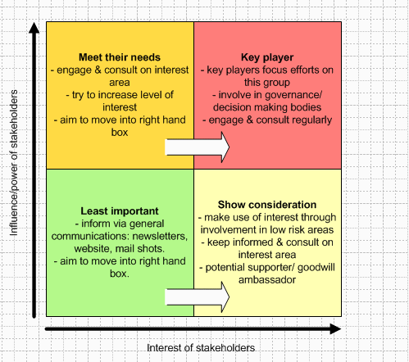

3.- Find Linkages between stakeholders

After placing the stakeholders in the graph, it is recommended to analyse the linkages that may exist between the different actors. How are they related to each other, how do they influence each other, who exercises power over another, who learns from another, etc.?

The Working Group can draw lines in different colours, expressing different type of linkage, going from one stakeholder to the other, in order to better understand who exercises more power, who works in a network, who is more impressionable, who is isolated, etc.?

In case it is a self-recovery project, don´t forget to place affected Households. It might be convenient to place in the graph as well potential audience groups for the project.

When finalizing, remember to take a picture of the analysis flipchart to keep record of the process and final conclusions.

**Transcribe discussion and finalize the Stakeholder Analysis**

At this point the Stakeholder analysis has been done. Now it is important to note briefly the main discussion points and conclusions in the excel sheet in order to keep track on the discussed points. The record should be very brief capturing only the main issues.

**How to complete the excel table – PART 2**

After going through the stakeholder analysis process and having reached a consensus, it is recommended to complete the template to reflect the discussion in writing. This will help to summarize and systematize the conclusions (part of the decision log).

**Part 2 – Analysis**

The columns G to M coincide with the questions asked in the first step of the stakeholder analysis methodology. Information can be completed while discussing or after having reached a final consensus. Column N and O are new questions, which should be added to the analysis.

In order to facilitate the analysis, start with the ‘key players’, continue later with the groups ‘meet their needs’ and ‘show consideration’, and finally analyse the group ‘least important’.

**Column G: Priority:** What is important to the Stakeholder? Key concern, Expectation, Incentive

**Column H: Motivation:** What could he motivate to participate in the project? What benefit could the stakeholder take from the project?

**Column I: Impact:** how does the project impact the stakeholder? High, Medium, Low

**Column J: Influence:** how much influence does the stakeholder have over the project? High, Medium, Low

**Column K: Trust:** how much influence does the stakeholder have over our target population? High, Medium, Low

**Column L: Supporter:** How could the stakeholder contribute to the Project?

**Column M: Opponent:** How could the stakeholder block the project?

**Column N: Attitude:** Perceived attitude towards the project or risk if not engaged

**Column O: Communication method:**

Here we want to identify how the specific stakeholder communicates and gets information. Try to think about, what are the most channels commonly used by this stakeholder to get informed or inform others? (e.g. informal chats with family and friends; community meetings; Newspaper; Radio; TV; Information from authorities; Information board; ....etc.) How is the best way to engage with this stakeholder? This should be just a global overview, as the Communication channel analysis will be another next step of the protocol, but it is convenient to start identifying them and assigning them to potential audiences or influencers.

**Column P: Actions**

Try to capture some ideas on how best to engage with this stakeholder to increase their interest in the project and enhance their support. This information will help to define potential activities or actions when developing the strategy.

**Column Q, R and S: Stakeholder analysis Conclusions**

To keep a record of the analysis done on the flip chart or board, transcribe the position you have given to every stakeholder.

In columns Q define the position on the vertical axe of the chart. High, Medium, Low

In column R define the position on the horizontal axe of the chart. High, Medium, Low

In column S enumerate the stakeholders with which they have linkages. The team can distinguish amongst the type of relationship identified, e.g. power relationship, cooperative relationship, informative relationship, learning relationship, etc.