Brief report from the field Visit 3-6/July/2009. Satkhira District.
Upazilas: Shyamnagar and Ashashuni

Places visited for the rapid assessment: Satkhira district, Shyamnagar Upazila, Gabura and Podhopukur unions.

Assessment team:

-Unit Local Officer of BDRCS Satkhira Unit,
-Md Nazmul Arefin (Miltu) Comitte member of BDRCS Satkhira Unit
-Mr Abu Qazi (Journalist) Comitte member of BDRCS Satkhira Unit
-Miguel A. Gómez. IFRC Shelter Delegate for Aila

(BDRCS: Bangladesh Red Crescent Society)

Update figures in the affected areas visited:

 |  | SHYAMNAGAR UPAZILA
UNION |  | Total Populat | Affect Populat | Families in embarkments | Remarks
Gabura |  | 30034 | 30034 | 3500
Podmapukur |  | 21163 | 21163 | 2500
Burigoalini |  | 27110 | 21448 | 900 | *
Munshigonj |  | 32768 | 22937 | 900 | *
Atulia |  | 28879 | 23103 | 1000 | *
Koikhali |  | 25694 | 15416 | 600 | *
Ramjannagar |  | 22211 | 9995 | 400 | *
Isharipur |  | 32095 | 9628 | 400 | *
TOTAL |  | 219954 | 153724 | 10200
According to the source, 80% of the affected population have returned to their original houses, and 20% of the affected families still are on the embankments.

Source: Mr Abu Bakar Siddique. Office Asstt-Cum-Computer Operator
Upazila Project Implementation Officer. Shyamnagar. Satkhira.
 |  | ASSASUNI UPAZILA
UNION |  | Total Populat | Affect Populat | Families in embarkments
Protapnagar |  | 32811 | 29529 | 2900
Sreeula |  | 29010 | 20887 | 1012
Khazra |  | 29738 | 20809 | 280
Anulia |  | 23818 | 16481 | 150
Assasuni Sadar |  | 25278 | 18707 | 210
Baradal |  | 28299 | 18960 | 0
TOTAL |  | 168954 | 125373 | 4552
Source: Mr Abdur Rhaman. Upazila Project Implementation Officer
 | Assasuni. Satkhira. Upazila Relief Department.

Main conclusions from the field visit

-The majority of the affected population (with the exception of a few unions) have returned to their original houses.

-According the sources, around 15.000 families are still living on the embankments in Satkhira District.

- There are high risks from natural hazards as landslides, flooding or high winds in the embankments (bad maintenance of embankments and high exposure to wind).

- The access to settlement locations is complicated. Although the condition of local road infrastructure till the nearest ferry or launch ports are in good condition, from this points the supply of relief assistance should be conducted by boats, and taking into account the seasonal constraints, this supply is complicated.

-Collective Centres in Gabura Union: 3 Cyclon Shelters, 13 schools, 4 madrazas, 2 community clinics (and probably others). These collective centres give refuge to more than 1000 families (according the local sources). These buildings should be assessed and alternative structures should be seek wherever possible to enable schooling and the rest of functions.

-A joint assessment with agencies and ngo’s should be highly desirable.

-Although should be recommendable relocate the most vulnerable affected families at a safe distance from the threats, these families need urgently support in “sheltering”.

-Local authorities interviewed (Chairman of Shatkhira Sadar Upazila, and Gabura Union elected members) agree the support of the most vulnerable families with temporary shelters on the embankments.

-One temporary shelter (2,5 x 6 m) costs around 5.000 tk, with bamboo structure, wood floor and 1 plastic sheet 6x4m.

Temporary shelter 2,5x6m (covered floor area: 15m2)

- 1kg nails 2” 128tk
- 1,5 kg nails 5” 161tk
- 1 kg rope 30tk
- 15 m2 wood 1” 2400tk
- 11 bamboo sticks 1750tk
- TOTAL: 4.860TK

One shelter can be built in 8 hours with one carpenter and two workers.

All these materials are available in the locals markets next to the most affected areas.

With these materials could be possible a covered floor area of 17,5m2 for a 5 members family, getting the minimum standards of Sphera Project, however the lack of physical land on the embankments make difficult these solutions.

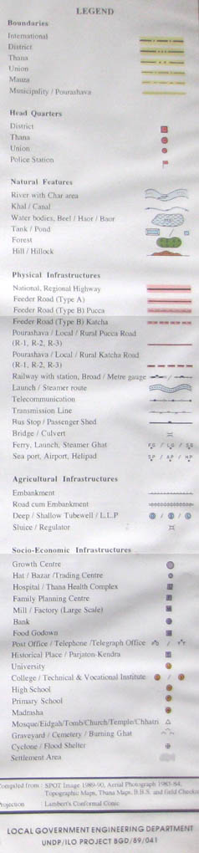
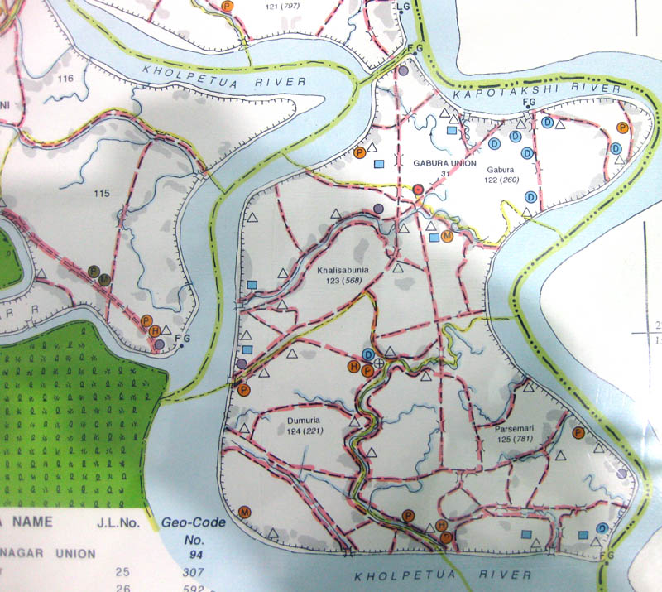
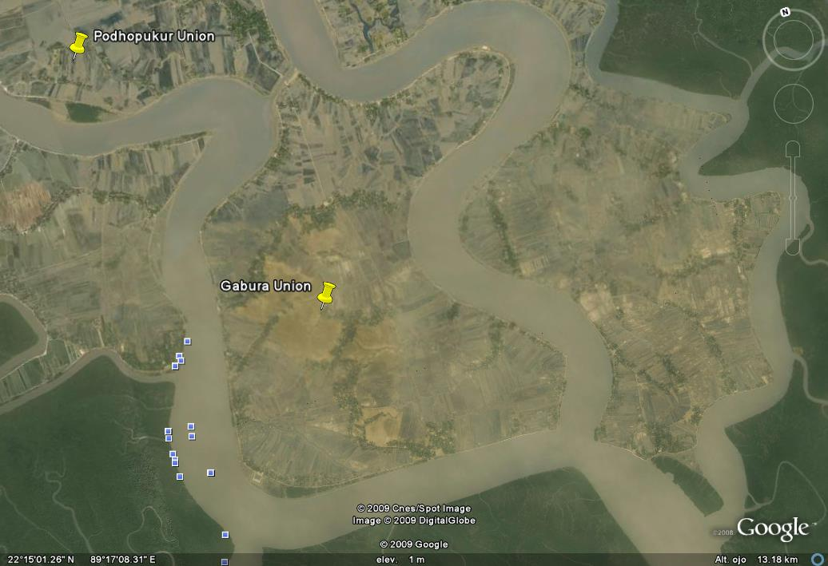
Gabura Union. Local Government Eng. Department.

Satellite view of Gabura Union. Google earth.

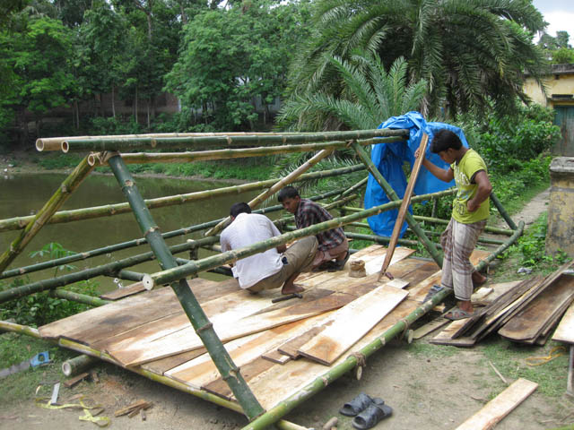
Shelter model 2,5x6m (BDRCS Shatkira Unit)

