

Global Shelter Cluster
1st Meeting of the Shelter, Cash and Markets Community of Practice (CoP)
28 April 2021, 11am – 12.30pm (Geneva)
Virtual (MS Teams)
Attendees: 28 participants
Co-facilitators/contacts:
Leeanne Marshall – lemarshall@redcross.org.au
Jennifer Weatherall – jennifer.weatherall@crs.org

- Context/Background
The Global Shelter Cluster launched the Shelter, Cash and Markets Community of Practice (CoP) in March 2021. The CoP is a place for practitioners to discuss and exchange on the use of Cash and Voucher Assistance (CVA) in shelter responses, and in relation to market analysis and market-based programming within the shelter sector. The CoP was formed following the deactivation of the Cash and Shelter Working Group (active from 2015 – 2020) to enable conversations, exchange, and technical discussions to continue in a more fluid and flexible format.
The 1st meeting of the COP was held on 28/4/2021 to introduce members to the CoP, generate interest and get inputs and feedback on the focus of the CoP going forward.
B. Agenda
- Introduction to the CoP Format and tutorial of the website
- Shelter Box update
- Updates on Rental Markets
- Cash Outcomes
  - Presentation by Somalia Shelter Cluster
  - Updates from USAID MPC Outcome review
- Next Steps

C. Actions
Action Point | By Whom | By When
CoP Co-facilitators to circulate a short survey to get further input from COP members on focus and format of the CoP | Leeanne and Jenny | May 2021
All members to post updates/questions on the CoP Discussion Group | CoP Members | Ongoing
Update on the roll out/next steps of the Shelter Cash Training developed by Save the Children in 2019/20 to be shared with CoP members | Renee | May 2021
2 or 3 individuals to volunteer to engage with the Co-leads and Reference Group of the Grand Bargain MPCA Outcome Indicators on behalf of the Shelter Sector. Contact Jenny and Jose if interested OR respond to the discussion thread: jennifer.weatherall@crs.org; jose.jodar@calpnetwork.org | CoP Members | 10 May 2021
Supporting continuous residence in the same rental housing unit beyond cash assistance: any agencies with experience to share on activities integrated in rental program design (e.g. accompaniment, case management, conflict resolution) that support this and/or strengthening relationships between Tenants and Landlords etc.) please share! Interested COP members to reach out to Miriam.Lopez@nrc.no (and use discussion forum on the CoP website) | CoP Members | N/A

D. Discussion Notes
- Introduction to the CoP format and tutorial of the website (Leeanne and Renee)

- The CoP Co-facilitators welcomed everyone to the new Shelter, Cash and Markets CoP. The CoP will be co-facilitated initially by Australian Red Cross (Leeanne Marshall) and CRS (Jenny Weatherall), with support from ShelterBox (Dave Ray) and the global cluster team (Renee Wynveen).
- It was agreed at the GSC meeting in 2020 that the former Shelter Cash Working Group had largely met its objectives and the best way forward was to evolve into a CoP
- The CoP is intended to be a space for practitioners to:
  - Share learning and good practices
  - Share new resources
  - Establish links with other sectors and areas of work
  - Facilitate the exchange and discussion of key areas
  - Identify priority issues that need to be addressed
- Since WGs are time bound, and specifically targeting deliverables, the CoP should be freer and more informal, and all members on the call are asked to support in facilitation! Anyone with an interest in cash and markets in the shelter sector are welcome to join.
- How will the CoP work?
  - Main webpage of the CoP: https://www.sheltercluster.org/node/19637
  - On the webpage, members can create a shelter cluster account and subscribe to the COP. All previous CWG members have been signed up to the COP
  - Once subscribed, members will receive notifications by email on any new content (including discussions, resources and news)
  - Discussion forum:
    - Discussion threads can be initiated by any registered member through the website or via email
    - By email: Send an email or question to: discussion-cash-shelter-markets@inbound.sheltercluster.org
    - On the website: Once logged in, reply to posts and discussions directly on the website
  - The CoP can also consider creation of smaller working groups to focus on particular technical topics. Sub-pages and discussions can be created on the webpage as needed to facilitate exchanges among partners.

- ShelterBox Update (Dave Ray)
ShelterBox shared their experience piloting Cash and Voucher Assistance in shelter programming. See attached presentation for more information.
Brief overview:
- Shelter Box is a UK-based organization, with only one office in the Philippines.
- Focused on relief, mainly goods in-kind
- Started looking at implementing CVA in 2016, and were engaged in the GSC Cash WG and now the CoP
- CVA is a complementary component to the in-kind work ShelterBox are doing, incorporating conditionality, restrictions and a focus on shelter outcomes
- Exploring global level Financial Service Provider (FSP) to enable delivery of cash in various countries (where Shelter Box does not have an office)
- Looking at a variety of cash transfer options:
  - Cash in envelopes by organization/partner
  - Cash collection at cash out points/agents
  - Cash in envelope by financial institution
  - Electronic transfer
- Have a global agreement with an FSP now, Western Union. Identified through a 2 year FSP selection process.
- Example from Philippines, for Typhoon Tisoy response in 2019
  - 27 days from disaster to first cash disbursement
  - Included a focus on shelter-focused outcomes within this 27 days (conditionality, restrictions)
  - ‘opt in’ process, and lots of discussion with communities to determine the transfer value, design (e.g. restrictions and conditionality) and delivery method.
  - PDM findings:
    - Spending focused on the items/services promoted by the team
    - Tranche based system related to receipts. People found it relatively easy to meet this requirement.
  - Team are now doing a follow up piece ‘one year on’ working with local government and community to see how the situation is now, and how the cash component assisted people in their recovery

Q&A:
- Q: How does this 27 days for a cash response compares with the time for other modalities (e.g. experience doing in-kind) - was it quicker/same/slower? A: Time period for response was the same: cash was provided alongside in-kind. ShelterBox try to provide some form of assistance as quickly as possible.
- Q: Can you share more on the Cameroon experience of ShelterBox? A: Working with a partner in the far north region of Cameroon and team have been doing cash with a partner over the last few years.
- Q: What was the amount provided in the Philippines? What was this based on, emergency needs or more sustainable shelter solutions? A: Two packages were developed based on targeting totally and partially destroyed shelters. Team looked at rough volume of materials people would need and local market prices. Cross over between relief and recovery, as the relocation was intended to be permanent. Provided shelter kits and CGI in-kind, and the cash was intended to support a more durable solution (i.e. ‘build in place’). Saw people build temporary structures, and then use own capacities and assistance from others to develop structures further. When the case study is more complete the team will be able to share more.

- Updates on Rental Markets (David Dalgado, British Red Cross)

- Rental assistance guidelines have been launched last year. Now available in English and Spanish, and currently being translated to French and Arabic. Available here: https://www.sheltercluster.org/shelter-and-cash-working-group/documents/ifrc-step-step-guide-rental-assistance
- Document was quite long, so a shorter tip sheet has been produced. This should support advocacy with donors and talking with field teams on the main steps in rental programming
- An online self-guided 1 hour training is currently under development and expected to be finished in a few months.
- David/Marta will share the links to the training, and tip sheets with the CoP once available.

- Cash Outcomes
  - Presentation by Somalia Shelter Cluster (Padmore) – for more info see attached presentation
Intro
- Cash-based interventions have been used by humanitarian organisations in Somalia since 2003; multiple mechanisms used (voucher, mobile money, electronic cash, cash in hand)
- Shelter cluster has been sharing its cash response data with the Somalia Cash WG, which coordinates both sectoral and MPCA response
- Since 2018, the cluster committed to delivering more than 50% of shelter/NFI assistance through cash using the mantra ‘why not cash?’
- Since 2020, seeing an increase in assistance delivered through cash > 25% of assistance under the shelter cluster delivered through cash in 2020 (second highest among all clusters in Somalia, after FS cluster)
Rationale for cash response in Somalia
- High insecurity and poor road infrastructure that makes transportation of shelter/NFI kits very difficult
- Packaging items with organisation logos is also a security risk
- Shelter/NFI kits are bulky and expensive to transport by air
- PDMs have shown cash to be preferred by beneficiaries
Challenges in cash response in Somalia
- Gaps in market info. Partners don’t necessarily know if markets are functional
- Lack of capacity within local organisations: technical capacity to implement cash transfers
- Inability of markets to meet demands when there is a spike in demand (especially where there is an increase in demand for NFIs/shelter where there is displacement)
- Protection concerns
- Need for quality assurance in shelter construction (need to balance choice of beneficiaries, and ensuring quality)
Shelter cluster initiatives:
- Joint market monitoring
- Initiative of REACH, shelter, WASH, and education clusters
- Provide regular and updated monitoring info on a broad range of NFIs
- Supports teams to understand quality, price and availability of priority S/NFI items
- Data collection and analysis done quarterly
- Found that partners are using the JMMI data to make decisions on their programming
- NFI/Shelter Guidelines
- Mentions modalities, and each of the associated risks and mitigation methods
- Cluster is planning a workshop for S/NFI partners
- PDM and Post-Construction Monitoring tools
- Developed by the cluster for cash and in-kind responses
- Evaluates the appropriateness of each modality
- Seeks to identify the risks involved with each modality
- Evaluates the beneficiary preference in terms of modality
- Cluster will produce a consolidated report within a month with learnings, and will compile PDM data cross partners
Q&A:
- Q: does the PDM look at shelter outcomes or more the output or process level? A: The PDM monitors both: how the assistance is delivered, protection risks/issues etc as well as looking at improvements from the perspective of the recipients.

Somalia tools available: https://www.sheltercluster.org/standardized-tools/library/post-distribution-monitoring-tool and included in the Shelter Cluster Coordination Toolkit and the Shelter Cluster Information Management Toolkit.
  - Updates from USAID MPC Outcome review (Jose, CaLP) – see presentation for more information
- Updates on the revision process for the Grand Bargain MPCA Outcome Indicators were shared by CALP (one of the 3 co-leads of the MPCA outcome indicator work)
- Process and timeline:
  - MPCA outcome indicators developed in 2019, and now under revision under the Grand Bargain
  - Consultancy conducted in 2021, consulting 60 KIIs, and 30 survey respondents. Report currently being drafted
  - Reference Group will meet on 10th May to discuss findings and next steps
  - Aiming to draft the new indicators and guidance by June 2021
  - Keen to have inputs form the shelter sector by end of May 2021. Can be an iterative process with the focal points from the sector, and the reference group
  - Current shelter indicators are:
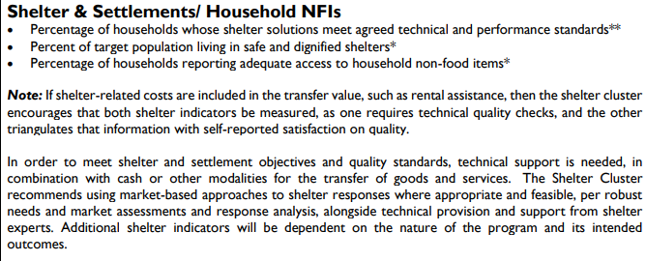
- Feedback so far on the shelter indicators:
  - MPCA will not impact the quality of the shelter
  - Indicators not used or should incorporate % of expenditures on rent
  - Incorporate indicators relevant to camp situations
- 3 options for the indicators being proposed based on the various sector feedback:
  - Option 1: Minimum number of indicators (2 or 3 max) without significant conditions on use
    - Would require the shelter sector to agree on universally appropriate indicators
    - Indicators could be opt in where appropriate
  - Option 2: Minimum number of indicators with significant conditions on use
    - Sector would include recommended indicators with conditions on when these should be considered for use (example: shelter indicators for MPCA only when sector specific programming is implemented alongside MPCA)
  - Option 3: No recommended indicators
    - if no minimum number of common indicators can be recommended with, or without, conditions then sectors can recommend to not have sectoral indicators included at all
    - could include expenditure data also to capture use of MPC for different sector needs
Q&A:
- Q: was it found that many agencies did actually use the MPC draft for field testing indicators, and if so how many examples of it use were found? A: Found a bit of everything, some people were using them but found it hard to see the changes with only MPCA, and also lots of examples where indicators weren’t being used pointing to the need to a) build consensus on use, and b) understand usefulness.
- Comment: Clarification needed on "shelter practitioners, did not understand the usefulness of having expenditure data” from one of the KIIs. Experience in Latin America, suggests it’s useful to have expenditure data on shelter, particularly related to rent. A: Quotes are not representative. Option is to consider that expenditure data might be useful (even if not related to outcome/impact).
- Next steps: COP members to volunteer if interested to take forward discussions with the reference group and the co-leads to make recommendations from the shelter sector. Respond to the discussion thread if members are interested to engage in further discussions. Indicators should be finalised by June 2021. If any questions, reach out to Jose: jose.jodar@calpnetwork.org

- Next Steps
Unfortunately time did not allow for a more detailed discussion to get CoP members thoughts on priorities for the CoP going forward. Instead, a survey will be circulated with CoP members to get additional feedback and inputs during May 2021.
Participants did response to 2 Menti polls to share ideas on (screen shots below):
- What are the most critical issues or topics you’d like to see the CP discuss, explore or focus on in the next 1-2 years?
- CVA restrictions  - Outcome tracking and monitoring (including shelter outcomes in MPC)  - Cash and inclusion  - CVA in relief period  - Digital opportunities  - Accompaniment  - Shared assessment tools | - Market assessment and market assessment best practices HLP  - Rental markets  - Evictions  - Links with other sectors  - Protection risks  - Advocacy for CVA  - Links to recovery
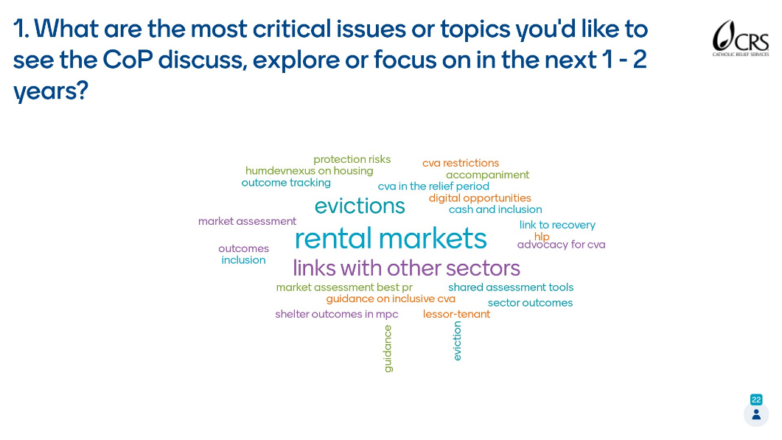

- What would you like to see form the CoP in the next 1-2 years?
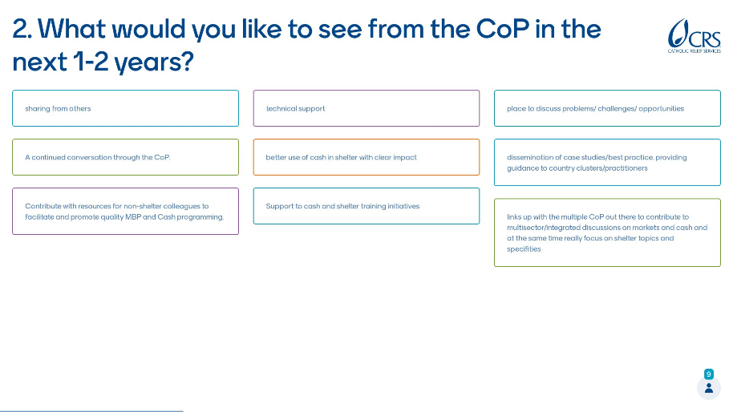
- Sharing from others
- Technical support
- A continued conversation through the CoP
- Contribute with resources for non-shelter colleagues to facilitate and promote quality MBP and cash programming
- Better use of cash in shelter with clear impact
- Support to cash and shelter training initiatives
- Place to discuss problems, challenges and opportunities
- Dissemination of case studies/best practices providing guidance to country clusters/practitioners
- Link up with multiple CoPs to contribute to multi-sector, integrated discussions on markets and cash and at the same time focus in on shelter optics and specificities

AOB:
We ran out of time to cover AOB items, but some suggestions were shared in the chat that members can take forward bilaterally or through the discussion forum.
- Red Cross (David):
1) Whether the Cash for Shelter training that Save and Jim K worked on was going to be rolled out, or was being used somewhere? I have recently helped with a Global Wash Cluster MBP training in Iraq, this seemed very organised and sustainable, with those trained then rolling it out to others. So the Cluster took the responsibility to them train the agency practitioners. I wonder if we can do the same in Shelter, or maybe we are already doing this.
2) I wanted to ask about how we capture our shelter spending using a CVA modality and whether we are collecting and publishing that information somewhere, or whether people saw the need to do this.

- NRC (Miriam): From the outcome monitoring and lessons learned of Rental Market Interventions, the *relationship* between the Lessors and Tenants is often the determining factor for a family to stay in the same housing unit – beyond the length of the cash assistance. I am interested in learning what specific activities are other agencies integrating as part of their project design (Accompaniment, Case Management, Conflict Resolution, etc.) Please reach out if interested and available.
Miriam.lopez@nrc.no
- CashCap (Jimena):
  - There are opportunities to keep the various CoPs in touch and connected, such as the Markets in Crisis (MiC) Markets in Crises (seepnetwork.org)
  - upcoming webinar on market assessments Making Market Assessments Fit for Your Purpose | Cash Learning Partnership (calpnetwork.org)

Reminder:
How to join the CoP:
How to Join: This CoP is intended to provide a forum for practitioners to continue to exchange, share resources and tools, and provide ongoing technical support in the area of cash and markets in shelter responses. To join the CoP, you should do the following:
- Create an account on www.sheltercluster.org
- Click ‘Follow’ on the left hand side of the Shelter Cash and Markets CoP landing page
- You will now be able to create and reply to discussions within the CoP and receive notifications when there are new resources and discussion threads
To write an email to the COP, please send an email to discussion-cash-shelter-markets@inbound.sheltercluster.org
Attachments:
- Presentations
- Recording

